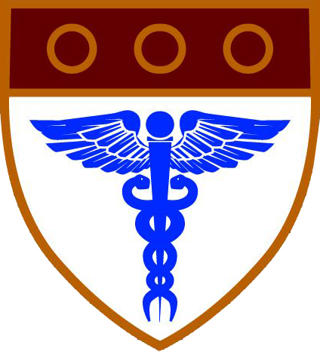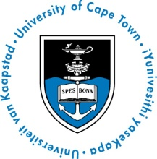

FACULTY OF HEALTH SCIENCES

UNIVERSITY OF CAPE TOWN

Communications and Marketing

Linda Rhoda, Manager

tel. +27 21 406 6685 fax: +27 21 447 8955 or +27 86 612 6390

Faculty of Health Sciences, P/Bag X3 Observatory 7935

[linda.rhoda@uct.ac.za](mailto:linda.rhoda@uct.ac.za) www.health.uct.ac.za

**MEDIA RELEASE**

***Driving Research for Human Health in Africa***

**UCT’s largest research entity celebrates ten years of cutting-edge research on diseases in Africa, 2 – 4 November 2014**

Featuring talks by world-leading researchers, an anniversary symposium will highlight the significance of the Institute of Infectious Disease & Molecular Medicine (IDM) in advancing research into diseases affecting Africans. Opening addresses commencing at 16h00 on Sunday 2 November will include:

* Minister of Science & Technology Dr Naledi Pandor
* President of the SA Medical Research Council Prof Glenda Gray
* Prof Mark Davis of the Howard Hughes Medical Institute (HHMI) and Stanford University
* University of Cape Town (UCT) Vice Chancellor Dr Max Price.

**22 October 2014, Cape Town –** Minister of Science & Technology Dr Naledi Pandor, President of the South African Medical Research Council Prof Glenda Gray, Prof Mark Davis of HHMI & Stanford University and UCT Vice Chancellor Dr Max Price will address the opening session of a symposium to celebrate the ten-year anniversary of the Institute of Infectious Disease & Molecular Medicine (IDM) from 2 – 4 November 2014.

Since its establishment in 2004, the IDM, which is based in the Faculty of Health Sciences, has become world renowned for its research to address diseases affecting Africans. It has grown into the largest research entity at UCT and a national leader in health sciences research and human research capacity development.

“The IDM is a trans-Faculty, multi-disciplinary postgraduate research enterprise that operates in the fields of infectious disease and molecular medicine research,” says IDM Director Prof Valerie Mizrahi. “World-class scientists work together to tackle diseases of major importance in Africa through cutting-edge basic, clinical and public health research. In addition, the IDM develops indigenous scientific capacity, and strives to influence health policy and practice by translating scientific discoveries and applying them in the community,” explains Prof Mizrahi. She adds that the IDM is distinguished by the ability to drive world-class research at the laboratory-clinic-community interface by engaging a wide range of scientific disciplines and that this unique environment draws substantial investment and enables significant output and, in turn, impact.

Members of the IDM have produced approximately 1600 scientific publications since its inception, which have been cited more than 34,000 times. IDM members raise approximately R250 million each year in research grants and contracts from predominantly international funders, forming a substantial portion of UCT’s research income.

Importantly, the IDM is a major training hub in Africa, for Africa, providing a pipeline for the development of researchers from their undergraduate scientific or clinical degrees, through postgraduate studies, to become independent researchers.

“This combination of high-quality, translational research with community engagement and investment in future research leaders uniquely positions the IDM to continue driving science in the service of the people of Africa,” says past Director, Prof Gregory Hussey, who played a key role in the phenomenal growth of the IDM.

“Under the symposium theme *Driving Research for Human Health in Africa*, our programme aims to capture core IDM values, identify future research directions, demonstrate capacity and thematic strengths and provide brainstorming opportunities,” explains Prof Mizrahi.

The symposium will commence on the afternoon of Sunday 2 November with a session that will feature the 3rd Annual Wolfson Memorial lecture. This lecture will be given by acclaimed immunologist Prof Davis, whose passion for driving better understanding of the human immune system, particularly in the context of vaccination strategies for infectious diseases, is of particular relevance to the IDM’s work. His presentation, *New approaches to analysing the immune response to vaccination or infection*, will elicit great interest. A cocktail reception hosted by Prof Hussey will follow.

The sessions on 3 and 4 November will see the participation of leading scientists from across the world. The sessions will showcase the cutting-edge work of internationally recognised, as well as ‘next generation’, IDM researchers across a range of disciplines.

Please click [here](http://www.idm.uct.ac.za/pdf/Programme_IDM_Symposium_2-4_November_2014.pdf) to see the complete symposium programme for detailed information on sessions and presentations.

ENDS

**Notes:**

The IDM was established under the direction of Emeritus Professor Wieland Gevers, as its Interim Director from 2004 to 2005. The Wolfson Memorial Lecture is held annually in recognition of the generous support given to UCT by Lord Wolfson of Marylebone and the Wolfson Foundation. The first Wolfson Memorial lecture was held in 2012 during the Faculty of Health Sciences centenary year.