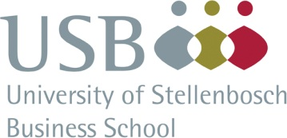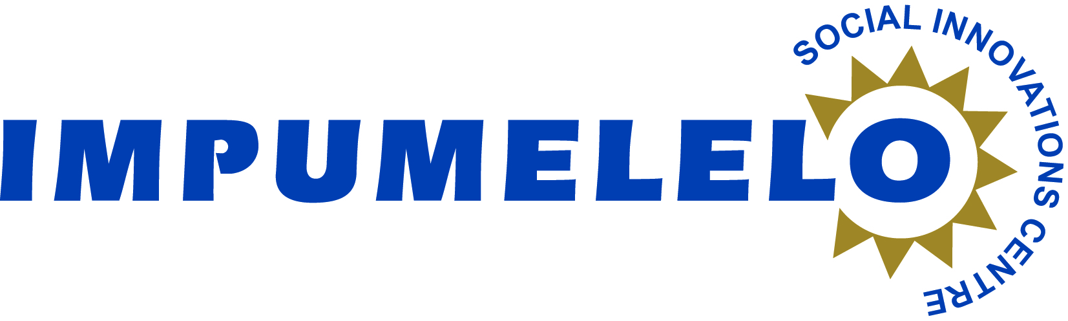

**IMPUMELELO SOCIAL INNOVATIONS CENTRE**

**IN PARTNERSHIP WITH**

**THE UNIVERSITY OF STELLENBOSCH BUSINESS SCHOOL (USB)  
HEALTH-CARE SUMMIT**

**“Innovative Strategies and Systemic Interventions to Improve Health-Care in South Africa”  
DATE:** Friday, 14 March 2014  **VENUE:** Auditorium, Room 210, USB, Bellville Campus

**Chair:** Ms Rhoda Kadalie  **Session 1 9h30 – 11h00**

**Welcome Speech: MEC Theuns Botha 15 minutes**

**Plenary** (Each Presentation is 20 minutes)

* Desmond Tutu HIV Foundation Sizophila Project Prof Linda-Gail Bekker
* FASD, Prevention and Intervention Ms Leana Olivier
* Administrative Support for TB Programme Ms Ria Grant

**Discussion (15-Minutes)**

**Tea 11h00 - 11h30**

**Chair:** Ms Marietjie Wepener(Marketing Director of USB) **Session 2 11h30 – 12h10**

**Panel 1** (Each Presentation is 10 minutes)

* ARV Clubs for managing large numbers of patients Dr Jannie Mouton
* Total Control of the Epidemic Mr Tonderai Chikono
* UKZN: 20 000+ Project PMTCT Dr Jennifer Reddy

**Discussion (10-Minutes)**

**Chair:** MsZohra Dawood  **Session 2 12h10 – 12h50**

**Panel 2** (Each Presentation is 10 minutes)

* SACTWU Worker Health Programme Ms Nikki Soboil
* TB/HIV Care Association: Project Integrate-Sisonke Prof Harry Hausler
* Closing the Gaps Dr M Youngleson

**Discussion (10-Minutes)**

**LUNCH 12h50 – 13h50**

**Chair:** MsRhoda Kadalie **Closing Session 13h50 – 14h40**

**Panel 3** (Each Presentation is 10 minutes)

* Perinatal Mental Health Programme Dr Simone Honikman
* Phelophepa Health Care Train Ms Shamona Kandia
* Umthombo Youth Development Foundation Dr Gavin MacGregor
* Uitenhage Eye Clinic Dr William Mapham

**Chair:** Dr Carol Thomas  **10-Minute Discussion and Concluding Remarks**

**Closing - Rhoda Kadalie**

**The Impumelelo Social Innovations Centre has been awarding innovation and best practice in various sectors aimed at improving the quality of life of the poor for 13 years. It has awarded over 460 projects with monetary awards to the value of R10 million. 13 of its projects have gone on to win international awards such as the United Nations Public Service Awards, the Dubai International Awards, the Schwab Foundation for Social Entrepreneurship and the Skoll Foundation for Social Entrepreneurship. This Health-Care Summit, in partnership with Liberty, and the USB, is an attempt to showcase the excellent work done by public/private partnerships that focus on the burden of disease in SA and initiatives that find solutions to rural health-care challenges.**

Rhoda Kadalie

**Executive Director**