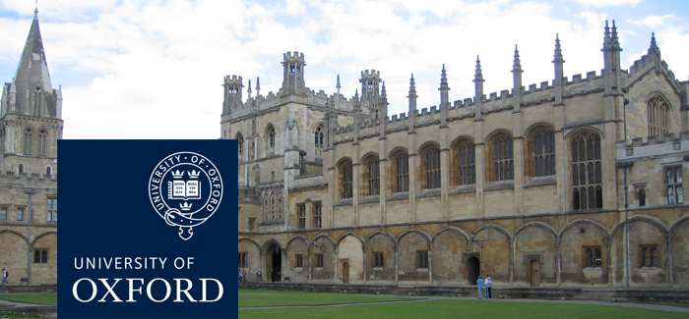

**Graduate Study at the University of Oxford Information Session with Oxford’s Vice-Chancellor, Professor Andrew Hamilton : 23 March 2015 at 16h00, LT1, PD Hahn building, UCT**

The University of Oxford is internationally renowned for its world-leading research, high-quality teaching, and excellent resources. Graduate students at Oxford join a diverse community of nearly 10,200 highly intelligent and committed fellow graduates from over 140 different countries. We admit graduate students of the very highest academic calibre and future potential, irrespective of nationality or other background. Whether our students are looking to join the next generation of academic researchers and teachers or build successful careers in other fields, Oxford’s outstanding academic staff and facilities serve as a strong foundation.

The University of Oxford offers around 200 separate taught Master's courses and 120 graduate research programmes in a wide variety of subject areas across the arts and humanities, social sciences, mathematical, physical and life sciences, and the medical sciences. See our website for a full list of courses available: www.graduate.ox.ac.uk/courses.

You are warmly invited to join the Vice-Chancellor of the University of Oxford, Professor Andrew Hamilton, to learn more about:

• The benefits of graduate study at Oxford

• Oxford’s 900+ fully funded scholarships

• Graduate life in the UK

• How to apply

There will also be the opportunity for you to ask any questions you might have about studying at Oxford and life in the UK.

DATE: Monday, 23 March 2015

TIME: 16:00 – 17:00

VENUE: Lecture Theatre 1, Department of Chemistry, PD Hahn Building, Upper Campus, UCT

BOOK: <http://conference.uct.ac.za/event.php?id=935176>