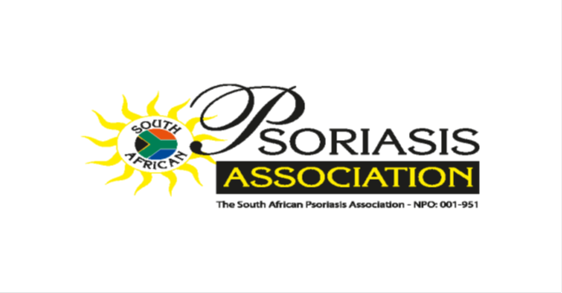



**Please join us in support of the Psoriasis Sufferers !!**



**DATE: Saturday 3rd May 2014**

**WHERE : WESTGATE Mall (Start/Finish) TIME: 8am**

**DONATION/REGISTRATION: R30 per ADULT**

**CHILDREN FREE**

**(*If accompanied by an adult*)**

**REGISTERED NURSES / DOCTORS ON CALL FOR ADVISE & INFORMATION ON PSORIASIS AND ECZEMA**

**FREE GIFT BAG WITH PSORIASIS RELATED ITEMS**

**For more info contact Alister on: 076 871 3924**