**Call for Applications:**

**CRG – Novartis – Africa Mobility Programme 2017**

**The opportunity**

In partnership with the multinational healthcare company Novartis, the **CRG – Novartis – Africa Mobility Programme** will allow four excellent late stage PhD students or early stage Postdoctoral Fellows from African Universities to conduct research at the Centre for Genomic Regulation (CRG) in Barcelona for six months. This programme aims to build scientific capability by enhancing the skills of local scientists and by facilitating the knowledge transfer to their wider scientific communities upon their return home. Excellent young scientists will conduct high quality supervised research in the fields relevant to the focus of CRG. The successful applicants will have access to CRG technologies and facilities, seminars, training programme, retreats, conferences and other scientific events. The visit will be fully funded (see below).

The fellowship will start mid-January 2017.

|  |
| --- |
| **Applications from University of Cape Town candidates must be submitted by email to Esmari Taylor at** [**research.health@uct.ac.za**](mailto:research.health@uct.ac.za) **by 12:00 midday on 8 July 2016** |

**About the CRG**

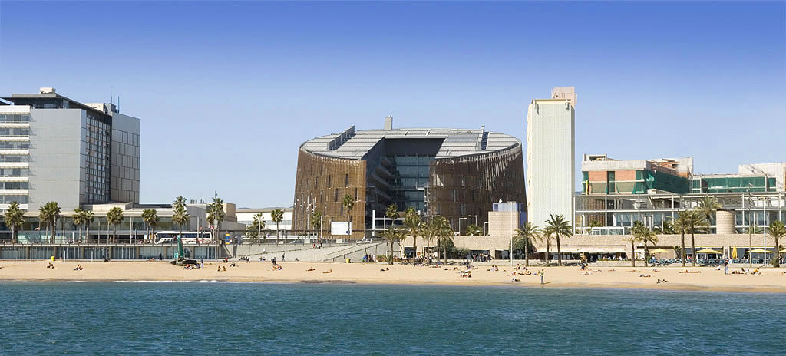

The CRG was founded in 2000 and benefits from the stimulating environment of Barcelona and the surrounding area of Catalonia. It is situated in a scientific hub for biomedical sciences in southern Europe that comprises over a hundred research centres, several universities, and research-intensive hospitals.

The CRG covers a wide spectrum of areas in basic biological research, from the study of gene regulation to the function of genes and proteins in cell structure and behaviour, their influence on the development and life of organisms, and their role in human disease. The centre has four Research Programmes, namely: Bioinformatics and Genomics; Cell & Developmental Biology; Gene Regulation, Stem Cells & Cancer; and Systems Biology. The research is supported by state-of-the-art core facilities that allow shared access to sophisticated technologies, such as proteomics, next generation sequencing, advanced light microscopy, high-throughput screening, flow cytometry, tissue engineering, and bioinformatics. In 2015, the CRG merged with the National Centre for Genomic Analysis (CNAG), therefore boosting its capacity in genetics and genomics.

In 2015 alone, CRG scientists published over 200 scientific papers with an average impact factor close to 9. Overall, the CRG offers a very stimulating, creative and international environment to do cutting-edge science in life sciences and biomedicine. Working language is English. You can read more about the CRG at: [***www.crg.eu***](http://www.crg.es/)***.***

**Eligibility criteria**

* This call for applications is open to all PhD students and Postdoctoral Fellows registered at an African University working in a relevant discipline.
* Preference will be given to:
  + Late stage PhD students who are already familiar with research techniques.
  + Early stage Postdoctoral Fellows.
* A research focus that aligns closely with that of the CRG.
* The applicant must have the approval and support of her/his current supervisor.
* Supervisors must be prepared to engage with the CRG scientists with regard to the research projects.

**Application process**

* Applicants are encouraged to visit the CRG website to familiarize themselves with the research undertaken at the centre.
* The proposed project can be an aspect of the PhD research or the projects currently undertaken by the postdoc. The shortlisted projects will be sent to the CRG to evaluate suitability with CRG hosts.
* Applicants must submit in electronic format (PDF):
  + Their academic CV
  + Motivation letter (1 page)
  + A description of proposed research that could be undertaken during the 6-month visit, written under the headings of (max. 5 pages):
    - Research question
    - Rationale
    - Work plan including time-line and budget (to be revised with CRG upon approval)
    - Expected outcomes
  + A proposed host(s)at the CRG who work in the area of the research question (please consult the CRG website)
  + A written endorsement by the applicant’s supervisor at the African University

**NB:** It is important to demonstrate your competence at relevant research methodologies.

**Selection**

A University of Cape Town pre-selection committee will assess the submissions. Criteria will include evidence of outstanding achievement to date by the student/postdoc; quality and suitability of the proposal; and fit with the proposed host groups at CRG. We strongly advise would-be applicants to make contact with their prospective host group at the CRG to discuss their intention to submit a proposal to help ensure a good fit with their research, and to describe this in their motivation for spending time there. The short-listed applications will be evaluated by CRG faculty in order to identify the best candidates and the best mutual overlap of scientific interests with CRG scientists. Skype or telephone interviews may be conducted by the CRG before final approval. Personnel at Novartis will also revise the applications. We expect to finalize the selection process by the beginning of September 2016.

**Duration of visit**

The fellowship will run continuously for 6-months from January to June 2017. Fellows should start their visit not later than end of January 2017.

**Fellowship:**

The fellowship will include an adequate stipend, medical insurance, travel, accommodation, Spanish course and bench fees up to approximately 18.000€. Please note that accommodation will be in a shared flat.

**Contacts:**

* UCT: Ms Esmari Taylor, [research.health@uct.ac.za](mailto:research.health@uct.ac.za)
* CRG: Dr. Michela Bertero, [michela.bertero@crg.eu](mailto:michela.bertero@crg.eu)

**The CRG**

