**Call for Applications:**

**CRG – Novartis – Africa Mobility Programme 2016**

**The opportunity:**

In partnership with the multinational healthcare company Novartis, the CRG – Novartis – Africa Mobility Programme will allow four excellent late stage PhD students or early stage Postdoctoral Fellows from African Universities to conduct research at the Center for Genomic Regulation (CRG) in Barcelona for six months. This programme aims to build scientific capability by enhancing the skills of local scientists and by facilitating the knowledge transfer to their wider scientific communities upon their return home. Excellent young scientists will conduct high quality supervised research in the fields relevant to the focus of CRG. The successful applicants will have access to CRG technologies and facilities, seminars, retreats, conferences and scientific events. The visit will be fully funded (see below).

The fellowship will start mid-January 2016.

|  |
| --- |
| **Applications must be submitted by email to Esmari Taylor at** [**research.health@uct.ac.za**](mailto:research.health@uct.ac.za) **by 17h00 on Monday 6 July 2015.** |

**About the CRG:**

The CRG was founded in 2000 and benefits from the stimulating environment of Barcelona and the surrounding area of Catalonia (see photograph below). It is situated in a scientific hub for biomedical sciences in southern Europe that comprises over a hundred research centres, twelve universities, and thirteen hospitals.

The CRG covers a wide spectrum of areas in basic biological research, from the study of gene regulation to the function of genes and proteins in cell structure and behavior, their influence on the development and life of organisms, and their role in human disease. The center has four Research Programmes, namely: Bioinformatics and Genomics; Cell & Developmental Biology; Gene Regulation, Stem Cells & Cancer; and Systems Biology. The research is supported by state-of-the-art core facilities that allow shared access to sophisticated technologies, as proteomics, next generation sequencing, advanced light microscopy, high-throughput screening, FACS, and bioinformatics.

In 2014 alone, CRG scientists published over 200 scientific papers with an average impact factor close to 9. Overall, the CRG offers a very stimulating, creative and international environment to do cutting-edge science in life sciences and biomedicine. Working language is English. You can read more about the CRG at: [***www.crg.es***](http://www.crg.es).

**Eligibility criteria:**

* This call for applications is open to all PhD students and Postdoctoral Fellows registered at an African University working in a relevant discipline.
* Preference will be given to:
  + Late stage PhD students that are already familiar with research techniques
  + Early stage Postdoctoral Fellows.
* A research focus that aligns closely with that of the CRG.
* The applicant must have the approval and support of her/his current supervisor.
* Supervisors must be prepared to engage with the CRG scientists with regard to the research projects.

**Application process:**

* Applicants are encouraged to visit the CRG website to familiarize themselves with the research undertaken at the Centre.
* The proposed project can be an aspect of the PhD research or the projects currently undertaken by the postdoc. The shortlisted projects will be sent to the CRG to identify a suitable CRG host.
* Applicants must submit in electronic format (preferably PDF):
  + Their academic CV
  + Motivation letter (1 page)
  + A description of proposed research that could be undertaken during the 6-month visit (maximum length 5 pages, minimum font size Arial 11, single spaced), written under the headings of:
    - Research question
    - Rationale
    - Work plan including time-line and budget (to be revised with CRG upon approval)
    - Expected outcomes
  + A proposed host(s) at the CRG who work in the area of the research question (please consult the CRG website)
  + A written endorsement by the applicant’s supervisor at the African University

**NB:** It is important to demonstrate your competence at relevant research methodologies.

**Selection:**

A University of Cape Town pre-selection committee will assess the submissions. Criteria will include evidence of outstanding achievement to date by the student/postdoc; quality and suitability of the proposal; and fit with the proposed host group at CRG. Ranked applications will be evaluated by CRG faculty in order to identify the best candidates and the best mutual overlap of scientific interests with CRG scientists. Shortlisted candidates will most likely be interviewed by the CRG. We expect to finalize the selection process by the end of July 2015.

**Duration of visit:**

The fellowship will run continuously for 6 months from January to June 2016.

**Fellowship:**

The fellowship will include an adequate stipend, medical insurance, travel, accommodation, Spanish course and bench fees up to approximately 18.000€. Please note that accommodation will be in a shared flat.

The 18.000€ is only for the project; fellowship/flight/accommodation go to another chapter and will be fully covered by the Novartis fund. The applicants should include an estimation of the budget for their proposal, which will be revised later on with the host PI if the candidate is accepted.

**Contacts:**

* UCT: Ms. Esmari Taylor, [research.health@uct.ac.za](mailto:research.health@uct.ac.za)
* CRG: Dr. Michela Bertero, [michela.bertero@crg.eu](mailto:michela.bertero@crg.eu)

**The CRG:**

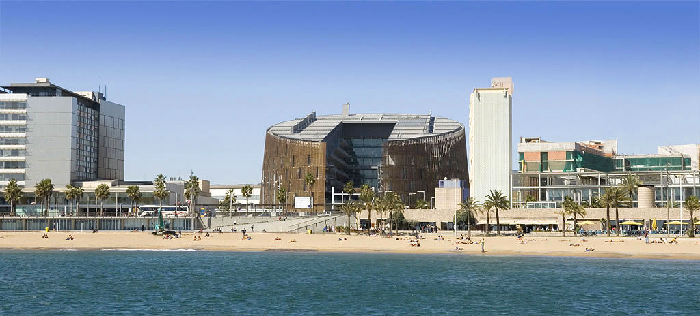

**CRG**