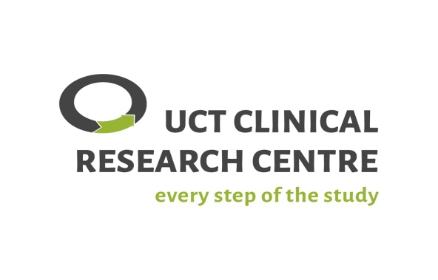 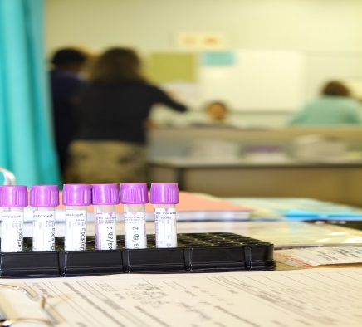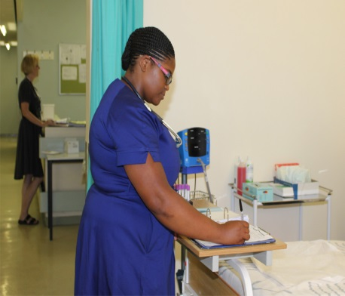

The UCT Faculty of Health Sciences has established a

**CLINICAL RESEARCH CENTRE**

where you can obtain free advice & tools, & also access

facilities for conducting your clinical research projects

**\*\*AVAILABLE TO ALL UCT CLINICAL RESEARCH STAFF \*\***

**\*\*\*\*FOCUS ON INVESTIGATOR-INITIATED STUDIES AND EMERGING RESEARCHERS \*\*\*\***

**What does the CRC offer?**

|  |  |
| --- | --- |
| **ADVICE, TRAINING, TOOLS &/OR SERVICES FOR:**   * UCT Sponsorship of clinical research * Obtaining grants & grant management * Study design, analysis & publication * Operational conduct:   + Data management   + Project & quality management   + Pharmacy-related issues   + Regulatory & other approvals   **Free to download documents and meet with**  **Centre personnel to discuss your needs** | **FREE DOWLOADABLE RESOURCES:**   * Standard operating procedures * Fact sheets * Other useful documents * Links to other relevant sites   **FACILITIES FOR HIRE:**   * 24-bed research ward, out-patient consultation rooms, pharmacy, processing laboratory, meeting rooms   **Fee-for-service for staff to work on your**  **study & for use of facilities** |

**FOR MORE INFORMATION CONSULT THE WEBSITE OR EMAIL US:**

[**www.crc.uct.ac.za**](http://www.crc.uct.ac.za)

[**crc@uct.ac.za**](mailto:crc@uct.ac.za)

