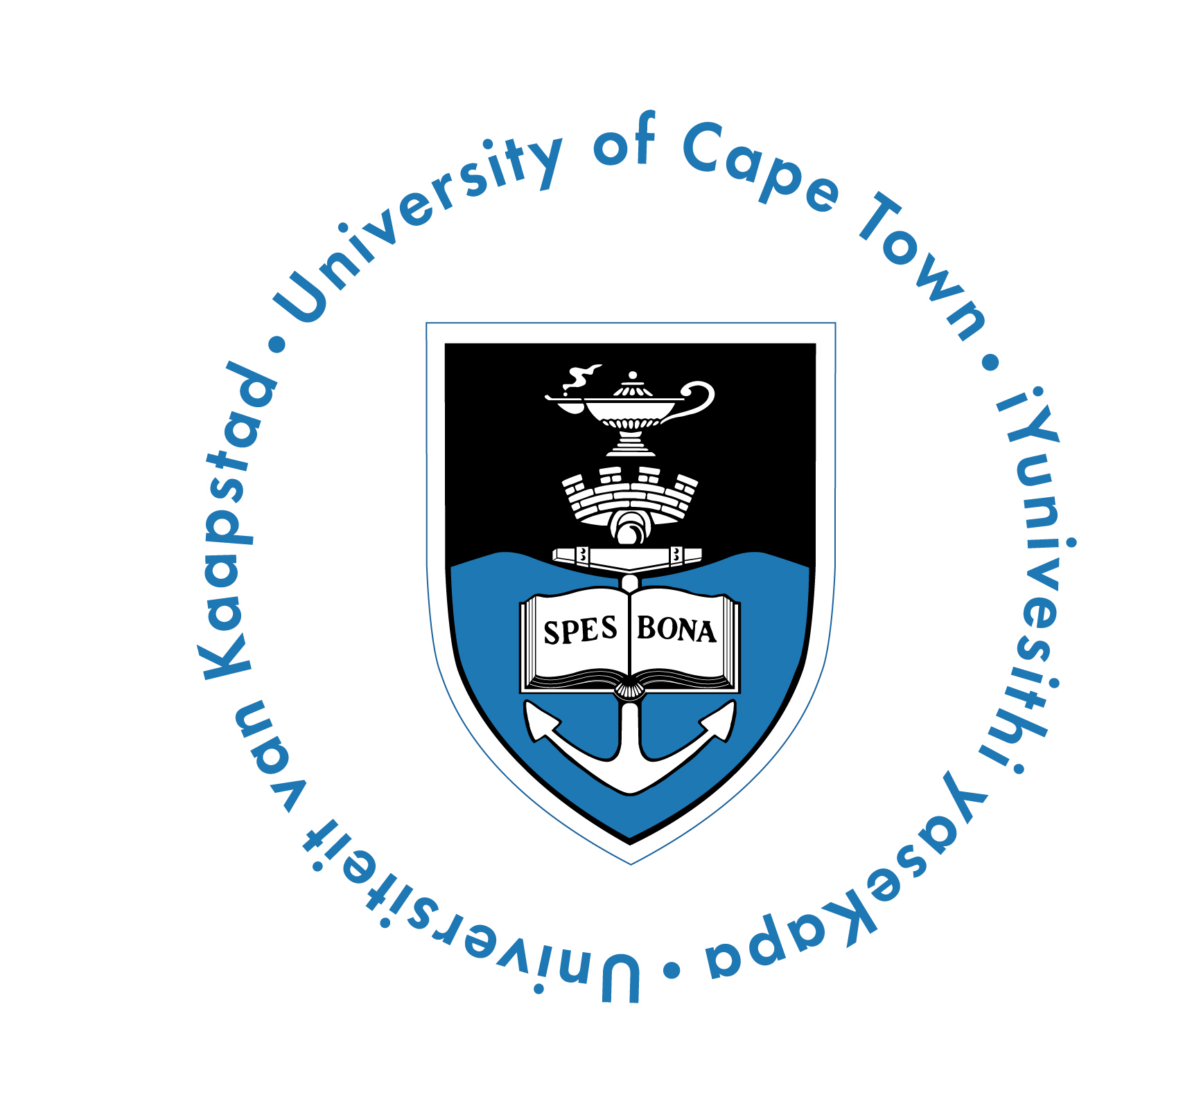

**UNIVERSITY OF CAPE TOWN**

**DEPARTMENT OF PSYCHIATRY AND MENTAL HEALTH**

**ACADEMIC LECTURES AND CASE DISCUSSIONS**

February-March 2014

Lectures and discussions on psychiatric, psychological and allied topics will be held as indicated on TUESDAYS at 12:45 in the AUDITORIUM, EDUCATION CENTRE, VALKENBERG HOSPITAL. These are open to all mental health professionals, university and hospital clinical staff.

Enquiries: 021 447 9306.

|  |  |  |  |
| --- | --- | --- | --- |
| **Feb** |  | |  |
| **04** |  | | “**Gender Identity disorder and adoloscents”**  Dr Pickstone-Taylor |
| **11** |  | | **ETHICS: “Values and Virtues in medicine”**  Prof Solly Benatar |
| **18**  **25**  **Mar** |  | | **O/G; ETHICS: “Prenatal diagnosis”**  Dr Chantal Stewart  **RESEARCH DAY** |
| **04**  **11**  **18**  **25** |  | **“Smoking cessation aids and neuropsychiatric adverse events”**  Prof Anthenelli  **“ Violence as a Problem in Public Health and Preventive Psychiatry: Towards a General Theory.”**  Prof Gilligan  **“Mental Health in Tristan da Cunha”**  Prof Brian Robertson  **ETHICS:** “**Sexual freedom and human rights**”  Dr Marlene Wasserman (Dr Eve) | | |